**Minutes of Meeting - AI Chat Bot**

Date: 31/08/2018

Time: 5.30 PM

**Attendance:**

1.Mohit Kumar

2.Purandhar Chilukuru

3.Vaishnavi Kattekola

4.Vaibhav Singh

5.Sarthak Tripathi

**Agenda:**

1. Our very first meeting was scheduled with Mr. Devulapalli Nagaiah who is the COO of the company where our discussion was about the introduction of the project.
2. He gave us a basic introduction of Mutual Funds and various other topics regarding investment in mutual funds.
3. We contacted him through Skype. A mail from our group had been sent to him for confirmation of the requirements mentioned.

**Snapshots:**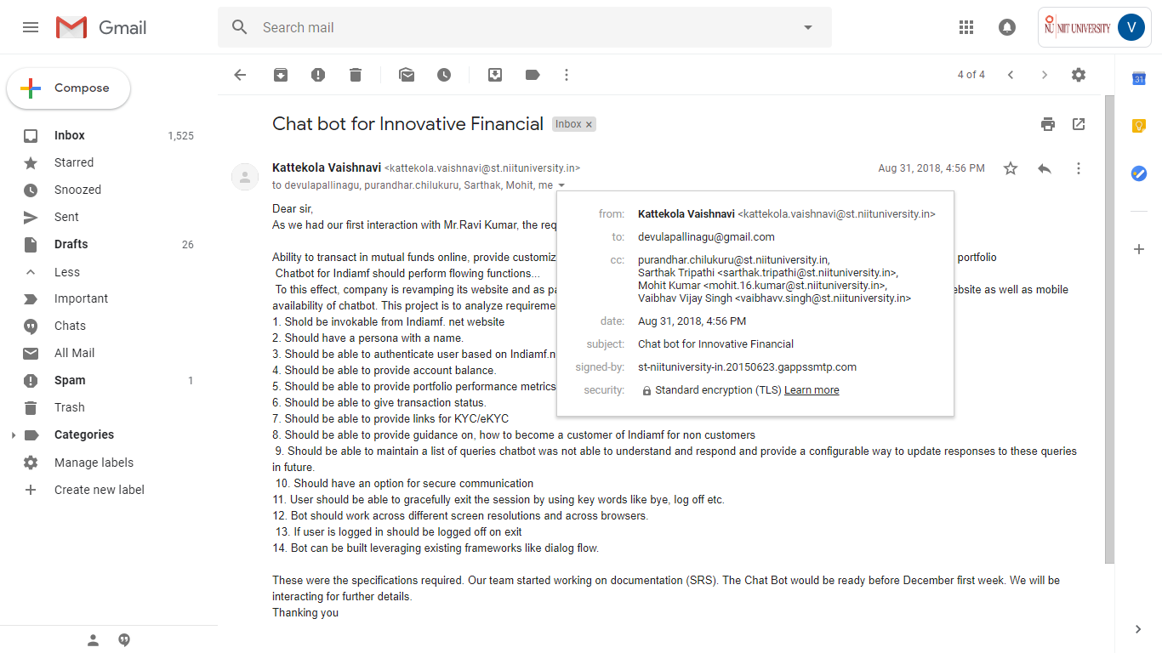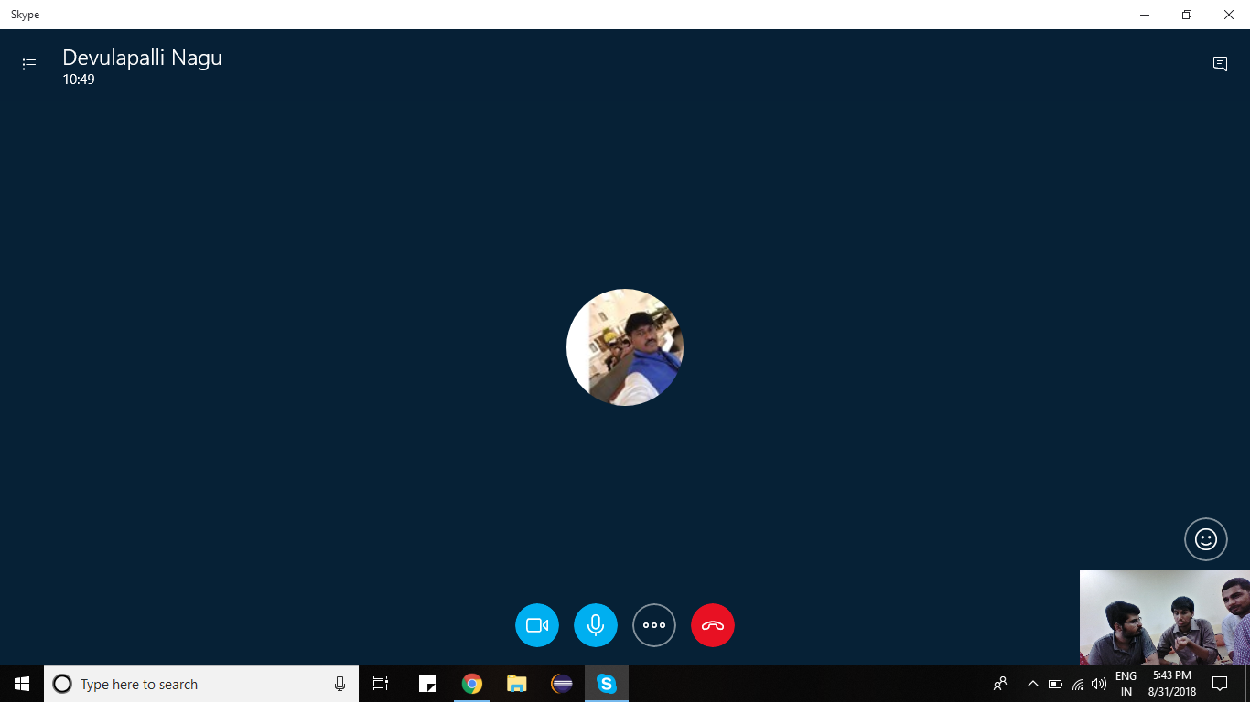

**Second Meeting**

Date: 09/09/2018

Time: 3.21 PM

**Agenda:**

1. In the second meeting Mr.Nagaiah discussed the basics of NSE(National Stock Exchange) and NMF II(A online platform which facilitates SIP)
2. Concepts of SIP(Systematic Investment Plan), features and motives of indiamf
3. Basic requirements of the Chatbot was also discussed.

A mail was sent from the company for the next meeting with the CEO and COO together for technical and functional discussion

**Snapshots:**

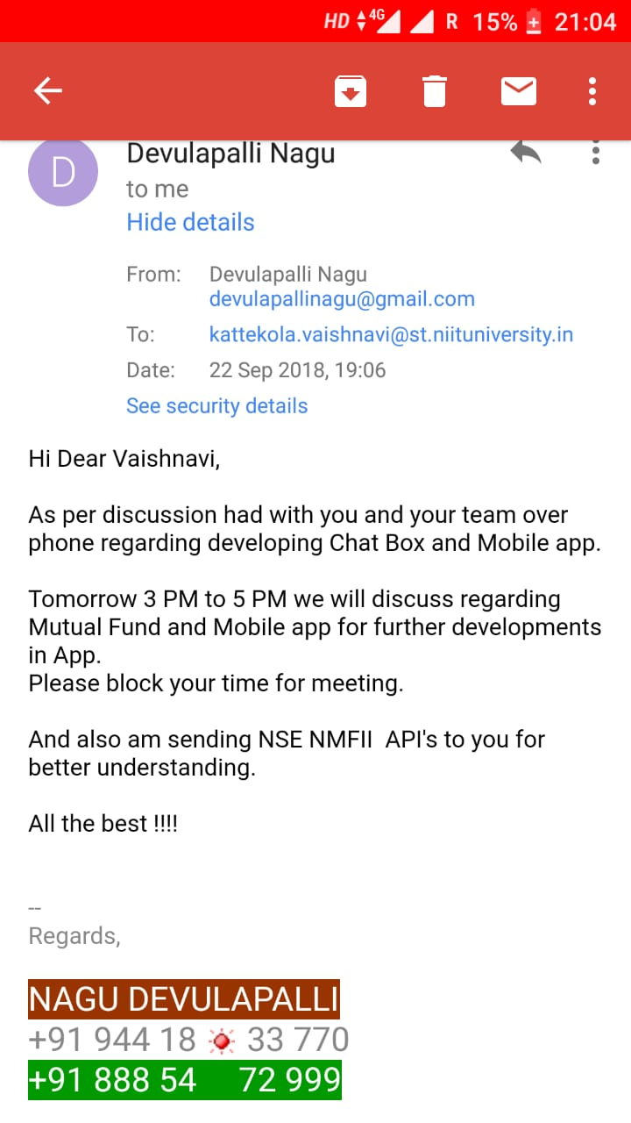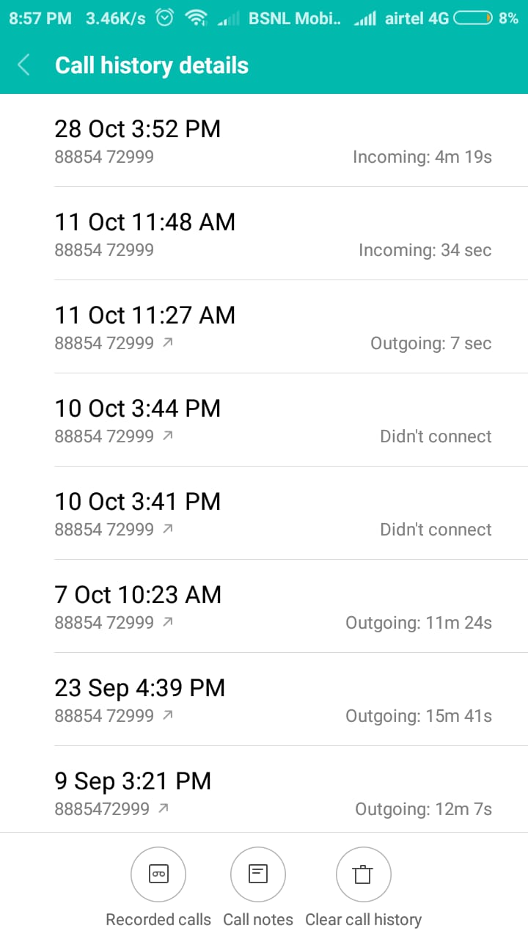

**Third Meeting**

Date: 23/09/2018

Time: 3.50 PM

**Agenda:**

1. Our next meeting was scheduled with Mr. Ravi kappagantu who is the CEO of the company and Mr.Nagiah where our discussion was about integrating our chat bot with his website. It was more of a kind of technical meeting.
2. He explained us in detail that on which platform their website was built and how we can integrate it with their website.
3. He also explained us about mutual funds transaction works or happen on the NSE platform.
4. They mentioned to use jira board for the updates of the project.

**Snapshots:**

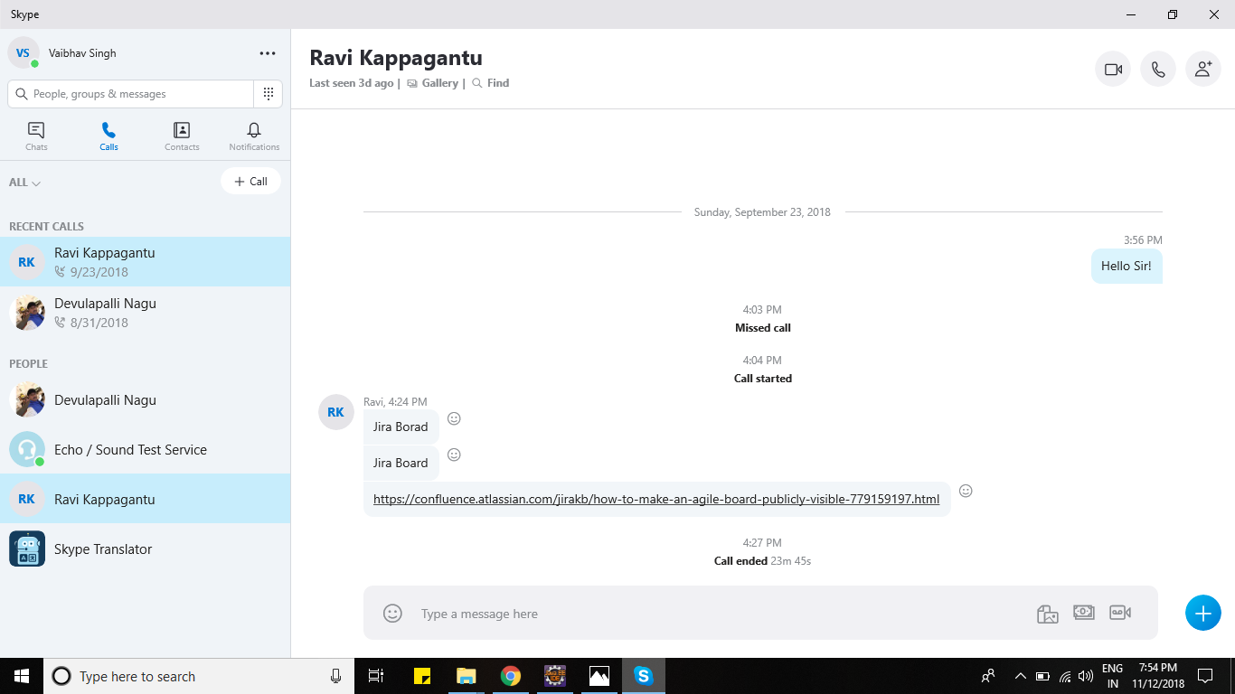

**Fourth meeting**

Date: 07/10/2018

Time: 10.23 AM

**Agenda**:

1. This meeting was just a follow up on the project with some general questions from us.
2. The detailed process of how registration and login of the users must be done was explained.

There was a small talk on scheduling next meeting on 28/10 as we cannot connect on 10/10 he called us on 11/10.

**Fifth meeting**

Date: 28/10/2018

Time: 3.52 PM

**Agenda**:

1. This is the final meet till date and as the project is almost done and just needs some final amendments in the database.
2. We discussed on sending the prototype soon for their checking and updates.
3. The meeting ended up by deciding to give the admin credentials to Mr. Nagaiah and their database of registered users would be provided to us soon.

**Latest Snapshot on our talk with the customer:**

